The Battle For Pass

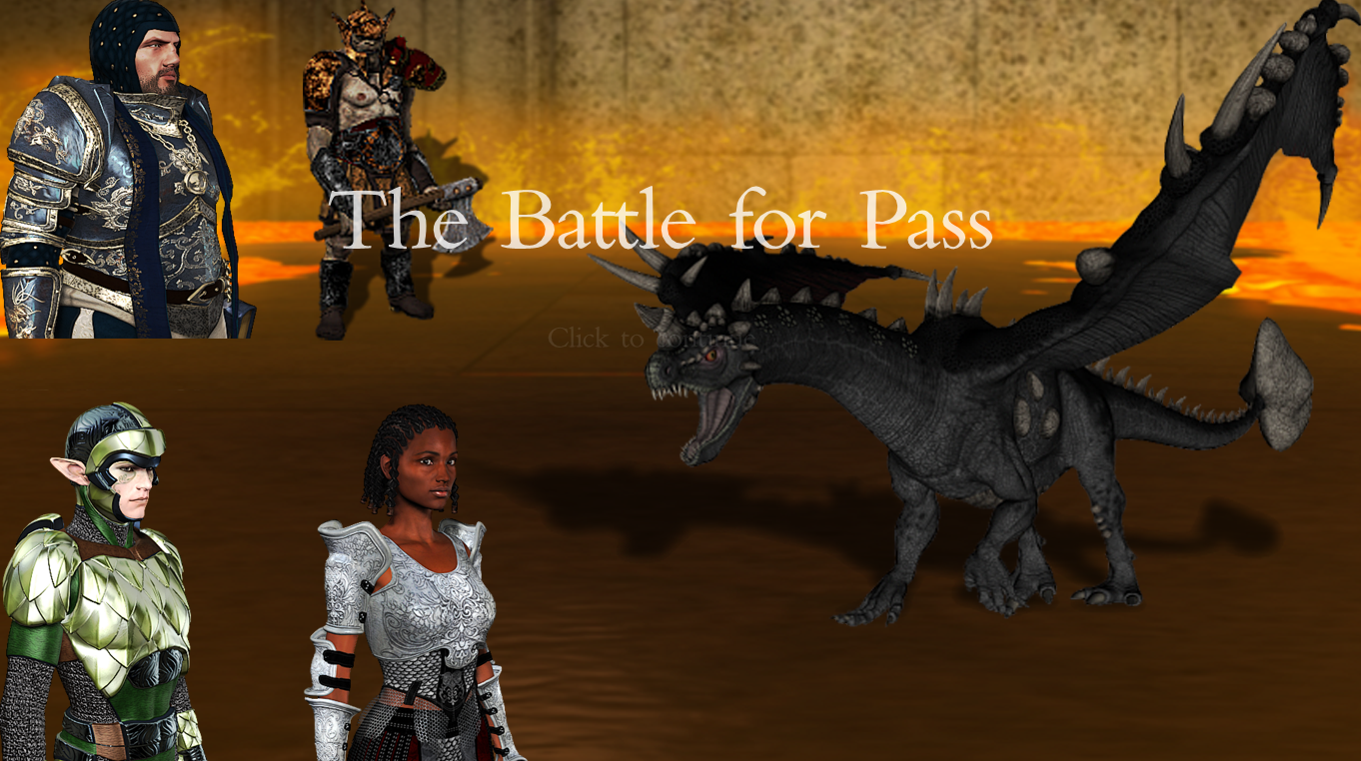

Marcos Vázquez Rey

Programación Avanzada, ESAT 2015

1. Intro to the Game Project

The Battle for Pass is an RPG game in which the player takes control of a valiant hero that must free the Village of Pass from an evil monster and its minions.
This game contains a total of 6 concatenated maps. The player must travel from first to last, and defeat the monster at the last map in order to beat the game (with the exception of map nº2, a house that can be skipped).

The source code for this project contains no propietary functions whatsoever, following the standards for C++11, and it has been tested to work without major problems in both Windows 7 and OS X 10.9 Mavericks.

There are some elements, both in-game and in the code, that serve as an example of how the game could be further expanded, but are not currently in use. For instance, the main menú contains buttons for game loading and options menú, but they lead nowhere. And the code contains several classes for Items (armor, weapon… etc.), that currently serve no purpose.

In adittion to the features strictly specified for this project, it incorporates, among others, the following improvements:

- An Intro screen

- A dynamic player creation screen -> Images are reloaded on button click

- A loading screen

- Integration with maps created with the editor Tiled

- A total of 6 different maps

- Passageways between maps

- Interactable NPCs

- Enemies on fixed positions, that can also be edited using Tiled

- Map collisions, setting which tiles can be walked on. This can also be edited with Tiled

- A total of 9 different enemies

- Battle Backgrounds that vary from map to map

- Player Sprites -> A total of 33 sprites per race/job combination (8 per every movement direction, plus one for dead character), and 2 additional images per race/job combination (face and bust/battler). This sums up to a grand total of 528 sprites and 32 images used for playable characters.

- Continuous movement -> The player movement on the map is made smoothly using animations and updated every single frame.

- Map persistency -> When entering a previously visited map, the player is at the correct spot, and not at a fixed point on the map.

- Healing potions -> They can be bought from merchants and used in combat

- A couple of easter eggs and references to other games ;)

- Unnecesarily detailed maps

- Enemy recognition on map -> When resting, the player is attacked only by enemy types that are present in the current map

- Magic -> Different classes have different spells available that suit them. Magic can be used in combat spending mana (magic points).

- A spells interface during battle

- A battle log detailing what’s going on

- An incremental difficulty system -> Every map contains thougher enemies

- A final boss and an end game screen

- A Game Over screen

2. Data Structures Specification

2.1 Folder Structure

assets

Contains all images, map files, sounds and fonts used by the game, and it’s divided into several sub-folders:
- raw -> Map files and images used by those map files.
- character -> Character images. The root holds images representing generic jobs. The following hold images for every combination of race/job.
- background -> Backgrounds for game screens and battles.
- enemy -> Enemy battlers organized by the enemy name.
- UI -> User interface elements (fonts and images)

include

Contains c++ header files organized semantically. These are the files to be included in each other.

lib

Contains source code for third party software and precompiled libraries. At this stage, it makes use of a modified TMX parser based on tinyxml2, in which support for base64 maps has been removed due to compatibility issues.

src

Contains source code for the project, method specification, extensive code commenting and it’s organized following the same semantic logic used for header files.

docs

A few documents about the development, including this very same document.

compile.bat

A simple script to automatize the compiling and linking process in Windows environments.

2.2 Logical Structures

Source code is organized semantically. Folders in both include and src follow the same structure and hold files that are closely related in terms of functionality, often inheriting from and including each other.

Character

Character is the base class that is inherited by all playable, neutral and enemy avatars.

Friend represents a neutral NPC.

Ally represents a playable character that has both a Race and a Job:

Race is an abstract class inherited by Human, Dwarf, Elf and Orc, each one of them having their own initial stats regarding health, mana, attack and defense.

Job is also an abstract class that is inherited by Boss, Hunter, Warrior and Wizard.
These apply modifications on the base stats set by the player race.

Enemy

This folder contains the classes for different types of enemies.

Foe is the abstract base class that inherits from Character and is inherited by all of the specific enemies.

All of the other classes representing enemies have the exact same methods inherited from Foe, and only differ in their stats.

Notice that all the enemies have MP=0, since they cannot cast spells and that field is, therefore, irrelevant.

These enemies originally appear on the map on groups of two per map. Here’s a list of the implemented enemies from weakest to strongest:
Brown_Asp, White_Asp, Harpy, Skeleton, Torturer, Troll, Soldier1, Soldier2, Black_Dragon.

That last enemy acts as a final boss, and a Game Won screen will be shown every time one of those is defeated.

Item

These classes are currently unused, although they broadly showcase how an inventory system could be implemented.

Main

This contains classes that have no direct relation with a specific group of other classes, are general-purpose or unclassifiable.

Misc is a static class containing general-purpose methods.

Grid is a bidimensional linked list of void pointers. It is mostly used for holding information about several data layers of a Map.

Map holds information about every one of the in-game maps, as well as a TMX parser and some code for displaying a loading screen.

Animation holds a collection of sprites and methods for extracting and displaying them in order. It is currently used for playable characters, altough it can be easily
expanded to show enemy, npcs or map animations, among others.

Manager is a singleton class that holds information about the current state of the game and is called by the majority of other classes.

Screen

These are the different screens, or scenes, or game stages, that exist in the project. Let’s list them in order of appearance:

Screen is the initial class inherited by all the others. It contains default method specifications and perform the GameLoop (input, update, draw).

Intro is the first screen displayed when running the game. It acts as a somewhat nice introduction.

MainMenu is where the player decides to start a new game or leave to desktop. This screen contains placeholders for “options” and “load game” buttons, altough they are currently not in use.

OptionsMenu is a class placeholder for a hypotetical future options screen. Currently unused.

NewGame is the character creation screen, where a name can be intruduced and a race and job can be selected. When starting the game, the player will be presented with a loading screen. This doesn’t have its own class, as it is a sub-process located in the Map class.

Game is the screen that shows maps, the character avatar and where the player is more likely to spend time in. It contains a bunch of boolean variables for storing the on-map status.

Battle is the screen that shows and processes battles between the player and an enemy character.

GameOver is a simple screen shown when the player is defeated in battle, and leads to the MainMenu.

GameWon works like GameOver, but is shown when the Black Dragon is defeated, and leads to the Game screen for the player to continue playing for as long as they like.

Spell

These are spells that the player can cast during a battle. Casting a spell in battle, unlike using a potion, will cause the enemy to attack in response.
Every spell showcases different possibilities.

Spell is the base class. All of the remaining classes in this folder simply set their own attribute values, and override the Cast method specifying what the spell does.

Blizzard directly damages an enemy, inflicting 20 damage regardless of defense.

FireSword temporarily increments the attack power of the player, making them accumulatively inflict more melee damage until the battle ends.

Heal restores a máximum of 15 health to the player, but never exceeding the player’s max_HP.

config.h

This single file acts as configuration for testing purposes. Note that a responsive game is not fully implemented and even though changing the resolution will not cause it to crash, some areas may not be properly displayed.

kNumMaps is used for testing and debugging purposes, when only the first N maps must be loaded in order to skip the whole loading process. Use this carefully as it may cause a game crash if the character steps on a portal leading to an undefined Map.

3. Strategies and Solutions to the Development Problems

4. User Manual & Game Example

